HACKATHON 3 (DAY 03)

API Integration and Data Migration

* Cloning the Project Repository :

To begin, I made a copy of my existing UI/UX repository by running the git clone [My Repo URL] command. Once the cloning was complete, I installed all required dependencies using npm install.

* Setting up Sanity :

After cloning the repository, I initialized Sanity in my project directory by running npm create sanity@latest.

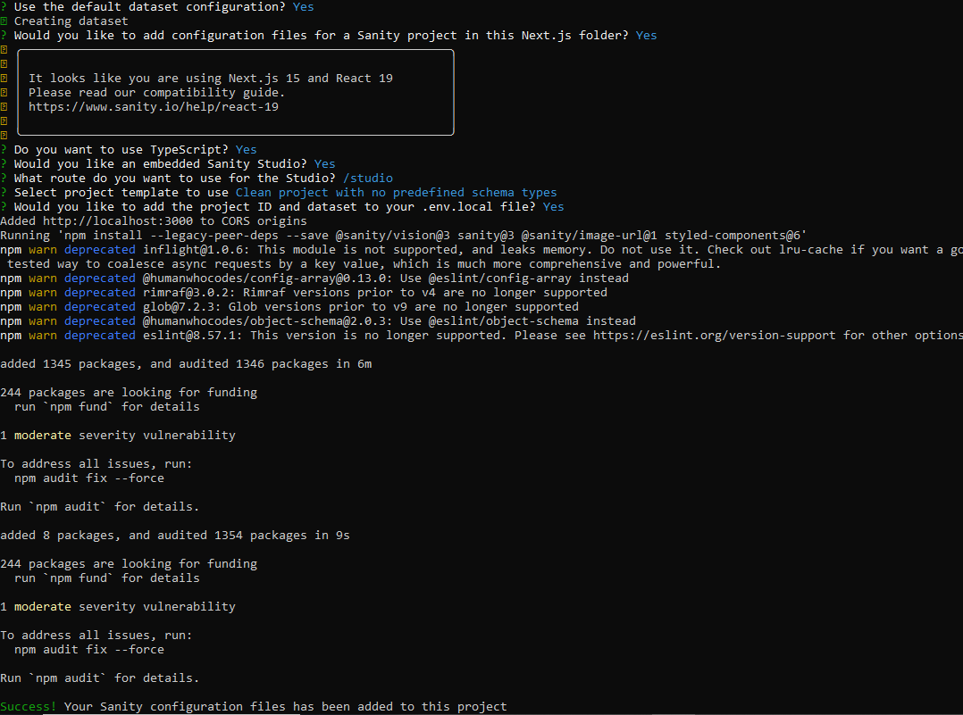

Once the setup was complete, I generated a **SANITY_API_TOKEN** from the Sanity dashboard. To do this, I navigated to my project,

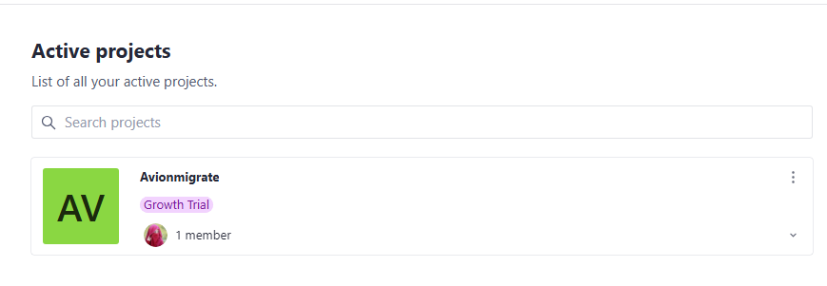

accessed the **API** tab, and located the **Token** section.

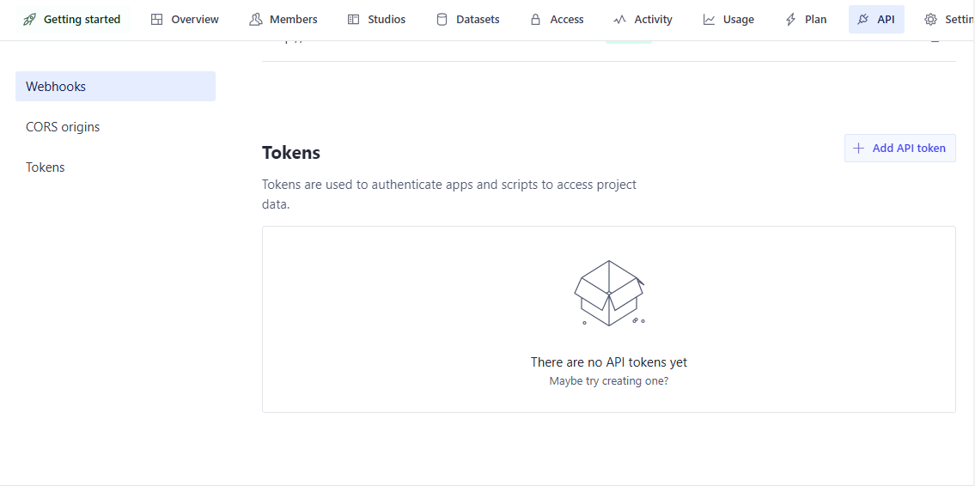

I created a new API token, set its permissions, saved it,

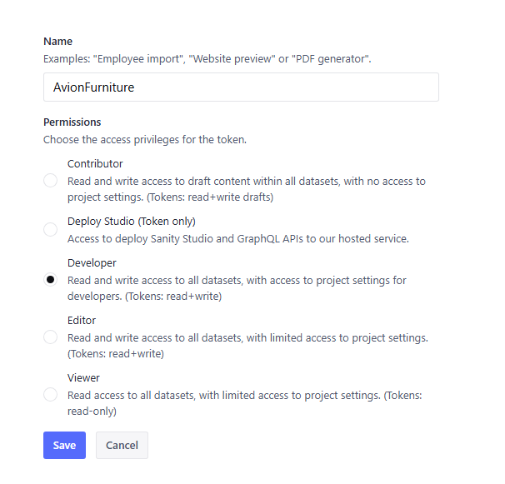

copied the generated token into my .env.local file.

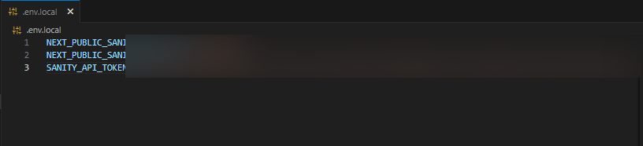

* Defining Data Schemas :

With the Sanity environment in place, I structured my data by creating schema files for **products** and **categories** inside the project.

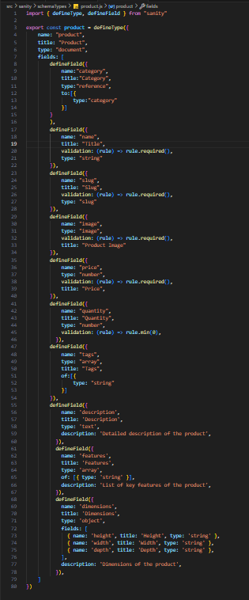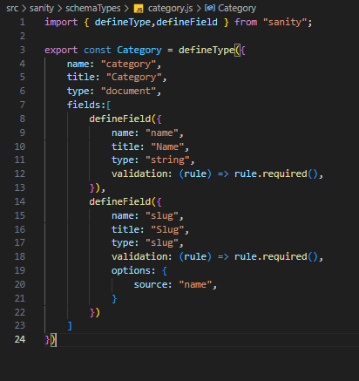

These schemas were then linked in the main configuration file to ensure proper integration.

import { type SchemaTypeDefinition } from 'sanity'

import { Category } from './category'

import { product } from './product'

export const schema: { types: SchemaTypeDefinition[] } = {

types: [Category, product],

}

* Migrating API Data :

To connect my frontend with Sanity CMS, I created a script to handle data migration.

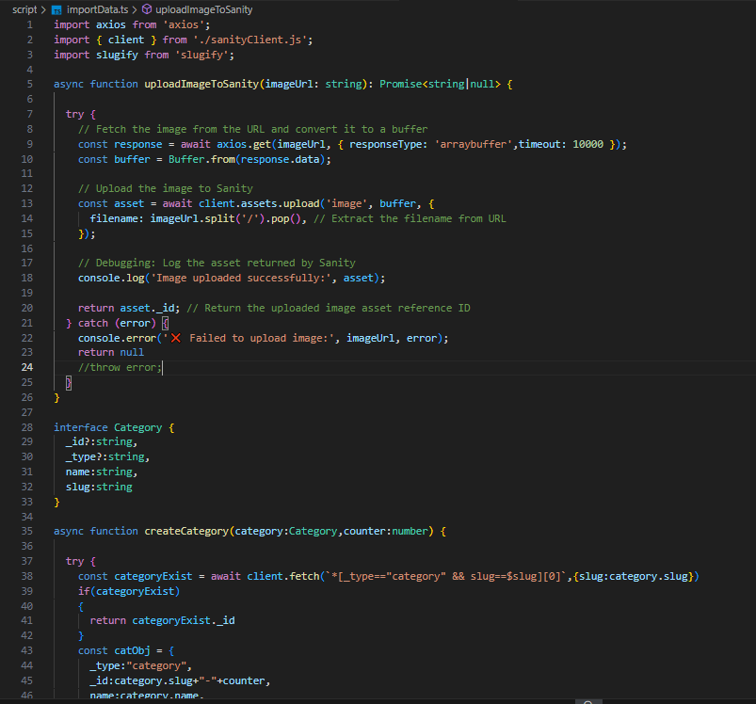

I installed necessary dependencies like **Axios** and configured my project to fetch and import data.

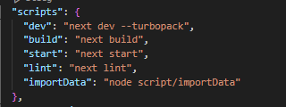

After setting everything up, I executed the import command, successfully migrating all API data into the system.

ON TERMINAL :

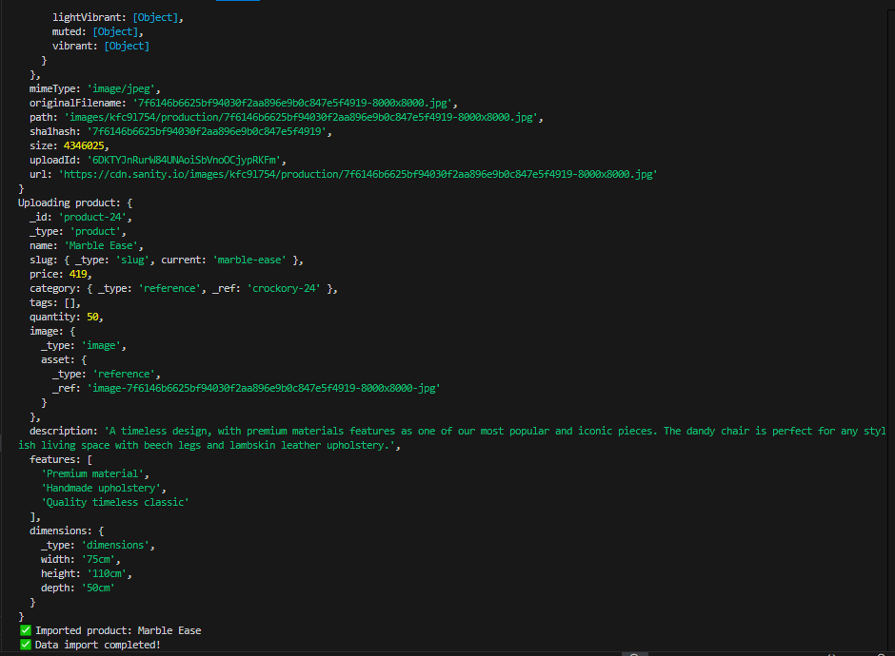

ON SANITY CMS :

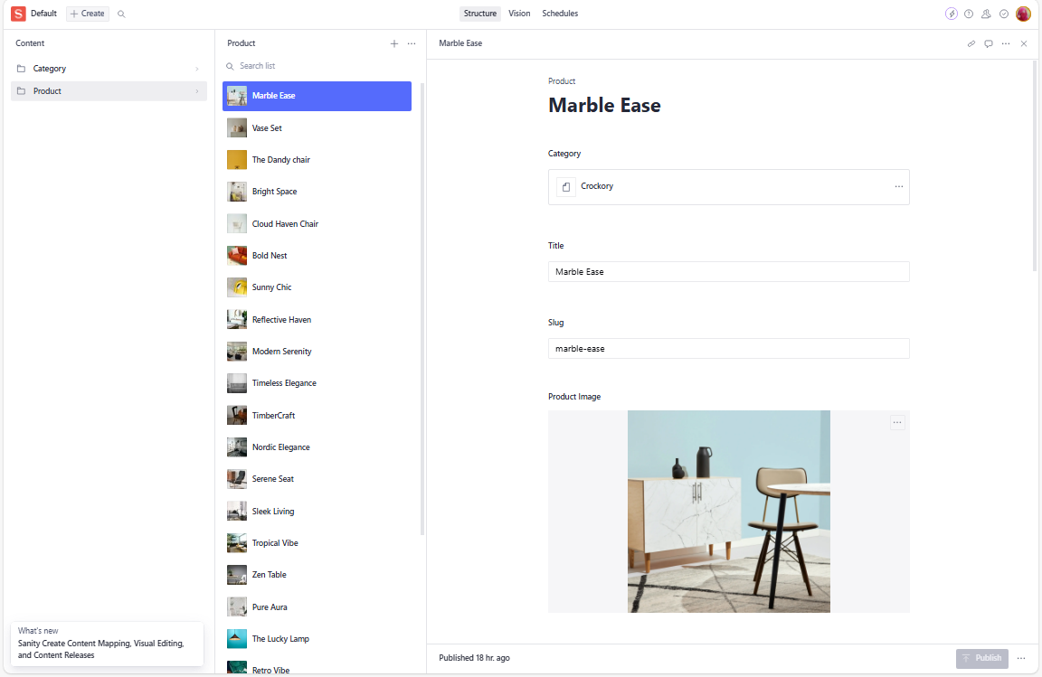

ON FRONTEND :

